Ray’s rentals

Final Submission

**Faran Azadi, Aamer Atique, Yusof Bandar, Naim Ahmed and Pritam Sangani**

Table of Contents

1.0 Executive Summary 4

2.0 Management Reports 5

2.1 Problems 5

2.1.1 Lost or Missing Documents 5

2.1.2 Data Sharing 5

2.1.3 Retrieving Data 5

2.1.4 Security 5

2.1.5 Cost 5

2.2 System Requirements 6

2.2.1 Bike Record 6

2.2.2 Rental Record 6

2.2.3 Maintenance Record 6

2.2.4 Parts Record 6

2.2.5 Sold Bikes 6

2.2.6 Customer Record 6

2.3 Data Enquiries and Management Reports 7

2.3.1 Data Enquiries 7

2.3.2 Management Report 7

2.4 Types of Management Reports 7

2.4.1 Analysis Reports 7

2.4.2 Key Target Reports 7

2.4.3 Exception Reports 7

2.5 Data Enquiries 7

2.6 Management Reports 8

2.6.1 Analysis Reports 8

2.6.2 Key Target Reports 9

2.6.3 Exception Reports 10

3.0 Use Case Diagram 11

3.1 Use Case Specifications 11

3.1.1 Update Customers Record 11

3.1.2 Update Maintenance Record 12

3.1.3 Update Bike Record 13

3.1.4 Order Parts 14

3.1.5 Update Rental Record 15

4.0 RDAs 17

4.1 Maintenance and Dealer Record RDA 17

4.2 Rental and Bike Record RDA 18

4.3 Merged RDA 19

5.0 ERDs 20

5.1 Top - Down ERD 20

5.2 Bottom – Up ERD of Merged RDA 21

5.3 Finalised Group ERD 22

5.4 Commentary of ERD Creation 23

6.0 Amended Group ERD 24

7.0 Data Dictionaries 25

7.1 Rental Record 25

7.2 Reservation Record 25

7.3 Dealer Record 25

7.4 Fault Report Record 25

7.5 Customers Record 26

7.6 Enquiry Record 26

7.7 Sold Bikes Record 26

7.8 Bike Record 26

7.9 Class / Size Record 27

7.10 Maintenance Record 27

7.11 Bike Parts Record 27

7.12 Supplied Parts Record 27

7.13 Ordered Parts Record 28

7.14 Manufacturer Record 28

8.0 Reflection on what has been learnt doing SQL 29

8.1 Aamer Atique 29

8.2 Faran Azadi 29

8.3 Naim Ahmed 29

8.4 Yusof Bandar 30

8.5 Pritam Sangani 30

9.0 Conclusion 31

9.1 Aamer Atique 31

9.2 Faran Azadi 31

9.3 Naim Ahmed 31

9.4 Yusof Bandar 32

9.5 Pritam Sangani 32

10.0 Appendices 34

10.1 References 34

10.2 Appendix A: Log Book 34

10.2.1 Part 1 34

10.2.2 Part 2 35

10.2.3 Part 3 36

10.2.4 Part 4 37

10.3 Appendix B: Presentation Slides 37

# 1.0 Executive Summary

The purpose of this project was to create a Information System for Ray’s Rentals Bike shop who still uses a paper based design. The report contains the steps taken to produce a working Information System model allowing Ray’s Rentals to improve his business.

The report outlines the problems with Ray’s Rentals paper based system and the typical management reports expected and a use case diagram (UCD) and a entity relationship diagram were outlined. Finally a database was created using SQL and Oracle which followed the two diagrams, providing Ray’s Rentals with a fully working Information System.

# 2.0 Management Reports

## 2.1 Problems

Ray’s Rentals currently uses a paper-based system for his bike shop. All data for the bikes such as type, unique ID and maintenance history is all noted down on paper, any reservations for a bike are also noted down on paper including customer’s details such as name and number. This paper-based system has already caused problems for Ray’s Rentals bike shop as described below.

### 2.1.1 Lost or Missing Documents

* The first problem with the current paper-based system is lost and missing documents. According to Cooper and Lybrand, “7.5% of all documents gets lost and 3% of the remainder is misfiled”. Ray has already stated that due to reservations being weeks in advance “that reservations can get lost among other reservations”. Being a paper-based system there are no backups if a reservation gets lost leading to reserved bikes being rented out to another customer. Furthermore, a paper-based list is occasionally out of date or inaccurate leading “to potential business is being lost through the, sometimes haphazard way in which enquiries are dealt with”.

### 2.1.2 Data Sharing

* A second problem is data sharing. Paper-based systems are located in one place, meaning that if Ray needed to access any records from home or share data with other employees this would be impossible. This lack of data sharing means a decrease in efficiency for Ray’s Rentals as data is only stored in one place, leading to a necessary spare part not being in stock which in turn leads to bikes being off the road for weeks for so long leading to lost revenue.

### 2.1.3 Retrieving Data

* Slow access to data is another problem of a paper-based system. Finding and retrieving data in a paper-based system is very slow and inefficient. It would be very difficult for Ray to retrieve any data about a certain customer or bike quickly if required. Also handwritten documents could be hard to read as someone might have bad handwriting. Reading the data would be easier on a digital system as it would be typed up as opposed to being handwritten in a paper-based system.

### 2.1.4 Security

* A fourth problem with a paper based system is security. With a database, the data can be encrypted and safely stored, this cannot be done with a paper-based system, making the current system vulnerable.

### 2.1.5 Cost

* One of the biggest problems with a paper based system is the high cost. All the problems stated above lead to a high cost system. Firstly, the cost of materials for Rey will be extremely high, noting down every detail about each bike and customer takes a huge amount of paper and storage. Furthermore, the cost of organizing documents to ensure document control and the labour cost is huge.

## 2.2 System Requirements

Below is a list of requirements that have been drawn up for the proposed new computerised database system for Ray’s Rentals.

To fully serve its purpose the new system should have 6 tables. The requirements for each table for the proposed new system are outlined below.

### 2.2.1 Bike Record

* This record should be used to keep track of all bikes that Ray’s Rentals have in stock. Each bike should have its own unique ID as per the current process.
* To improve usability, the record should include the option to filter by classification of, size, model, manufacturer and date of purchase of bikes that Ray’s Rentals have in stock.

### 2.2.2 Rental Record

* This record should be used to check for the availability of bikes for hire on any particular day and time.
* This record should also enable staff to enter customer details in order to reserve bikes and enter payment details

### 2.2.3 Maintenance Record

* This record should be able to flag up bikes that have not been serviced for a month
* Staff should also be able to update the record when bikes have been serviced
* There should also be a facility to record faults that have been reported by customers

### 2.2.4 Parts Record

* Staff should be able to use this record to check for stock levels of bike parts and be able to order parts that are low in stock. It could also flag up parts which are low in stock to reduce risk of missing parts that are low in stock
* This record should also allow staff to record deliveries of bike parts

### 2.2.5 Sold Bikes

* This record should allow the viewing of bikes that have been sold by Ray’s Rentals. Bikes that have been sold for two years should be deleted automatically from this record

### 2.2.6 Customer Record

* This record should be used to bring up details of customers’ who have reserved bike(s), such as name, address, the bike they have reserved and whether they have paid.

## 2.3 Data Enquiries and Management Reports

### 2.3.1 Data Enquiries

According to David Whiteley, a data enquiry is “the final type of report... All systems need to give the facility to look up each element of standing data and any transaction.” (Whiteley, 2013) In a database system, enquiries can be made about any details such as customer name, date or invoice. Usually, data enquiries are searched using a primary key, but can also be enquired by other details if the primary key is unknown. This is an operational level report; the output of the enquirer is usually displayed simply on the user’s screen. Data enquiries are a simple but efficient way of retrieving data.

### 2.3.2 Management Report

Management reports are used in organisations to outline how much money they have made or lost. These reports are utilised usually by high management or CEO/CFO’s so that they know how well the business is doing. These reports can be quarterly or annually depending on the size of the business and required purpose. The report can be used to strategize or see how well a new strategy is working.

## 2.4 Types of Management Reports

### 2.4.1 Analysis Reports

“The basic type of report is an analysis report that tabulates information on a two-dimensional grid” (Whiteley, 2013). Usually, an analysis report shows sales by region monthly, which can give a clear indication of how well Ray’s business is performing.

### 2.4.2 Key Target Reports

Key target reports are used to assess the performance of a business and “…would usually be aimed at the strategic and tactical management levels” (Whiteley, 2013). They usually compare the actual sales versus the targeted amount of sales.

### 2.4.3 Exception Reports

Exception reports are a summary considered out of the normal range. They are usually generated when an unusual situation occurs and requires specific attention. An example “…would be that of invoices not paid after a given period” (Whiteley, 2013)

## 2.5 Data Enquiries

Ray and his staff members will be making many data enquiries during the business’ operational hours. The enquiries made are usually relevant to the tasks required of the staff members. One scenario is when a customer requests to hire a specific bike. A data enquiry will need to be made by one of Ray’s staff to check if that particular bike is available to rent. A search/query could be made by searching the database using the model of the bike or the bike ID. Figure 1 illustrates this below.

Another example of a data enquiry at Ray’s Rentals is if a member of staff needs to know when a customer will be returning a bike. This could be because another customer is waiting for the same bike or the bike is due for maintenance, for example. An enquiry can be made using the booking reference and then checking the return date for that particular booking.

A third example is when Ray’s maintenance staff need to repair a bike. If they need to check if a part is available in the shop, they can simply do a search for the part using the part ID. If the part is available, the repairs can be done there and then. If not, the part can simply be ordered and the repairs can be scheduled.

Database

Search Result

Bike ID

*Figure 1*

## 2.6 Management Reports

### 2.6.1 Analysis Reports

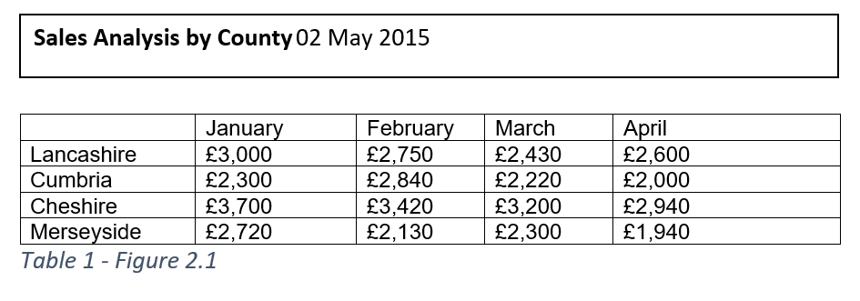

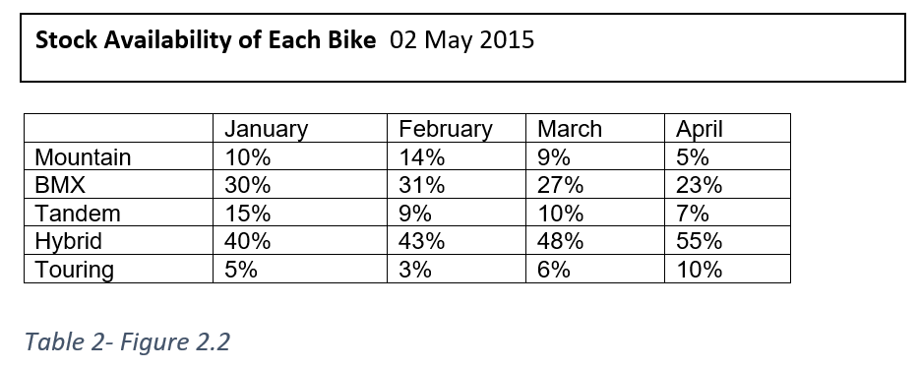

Tables figure 2.1 and figure 2.2 show data enquiries about Ray’s bike shop. Figure 2.1 is a data enquiry about the sale figures for the first quarter for 2015 of 4 counties in the North West. Figure 2.2 is a data enquiry about the stock availability of 5 different bikes which Ray’s bike shop offers for the first 4 months of 2015. Ray will be able to make data enquiries for future months and years.

Another example of a data enquiry Ray could make is to check which of the bikes Ray has the highest demand for, so, for example, Ray may want to buy more mountain bikes rather than buying BMXs as they are not really sought after in each of the counties.

### 2.6.2 Key Target Reports

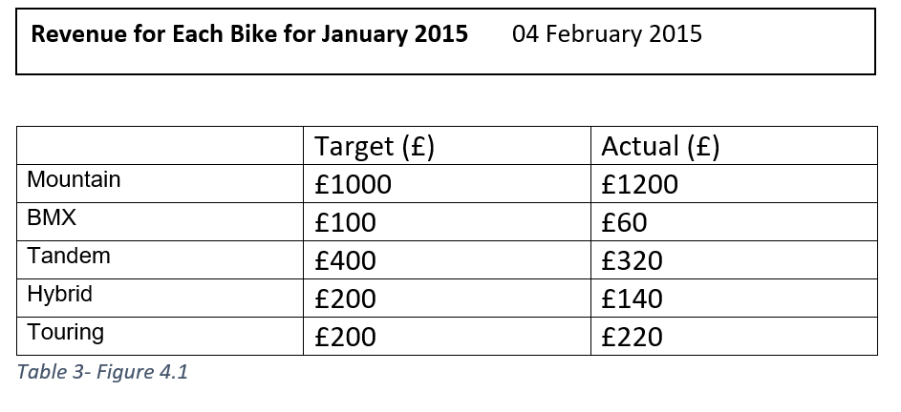

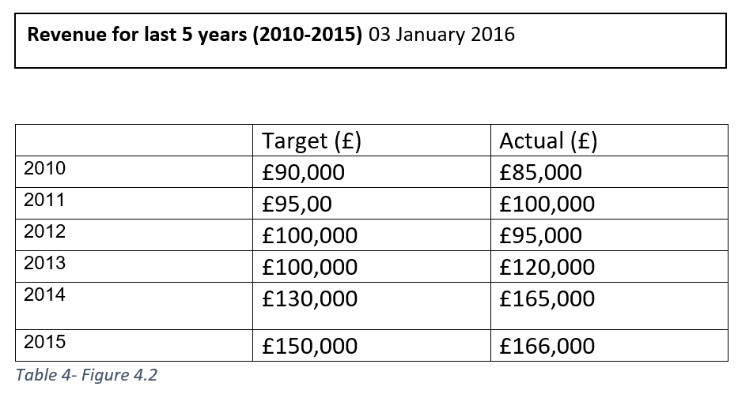

Tables figures 4.1 and 4.2 show data enquiries about the revenue for Ray’s bike shop. Figure 4.1 is a data enquiry about the revenue for the month of January 2015. The figures show the targeted revenue for each bike and the actual sale figures for each of the bikes. Figure 4.2 shows the data enquiries for the revenue made from the past 5 years (2010-2015) comparing the target revenue with the actual revenue.

Another example of a data enquiry Ray could make is to determine whether the business is viable and that it is making him money rather than losing him money each year. This could be used to check whether people are interested in renting out bikes.

### 2.6.3 Exception Reports

Exception reports, unlike analysis reports, will show Ray things that need ‘sorting out’ in the business. However, the chances are that Ray will need more information known as diagnosis information before he can understand or attempt to rectify the problem(s). If this does happen to be the case, an interactive report is produced. Generally, diagnosis information is accessed via the click of a button to avoid clutter on the page. An example of an exception report at Ray’s Rentals could be a list of all the customers that haven’t paid for the rental of a bike yet with the diagnosis information being the customer’s contact details such as phone number, address, e-mail etc. which will enable Ray or his management to deal with the problem directly. An example of this is below.

|  |  |  |  |  |  |
| --- | --- | --- | --- | --- | --- |
| Customer ID | Name | E-mail | Address | Total Owed | Paid |
| 1234 | Joe Bloggs | [j.bloggs@mmu.ac.uk](mailto:j.bloggs@mmu.ac.uk) | 123 Oxford St, Manchester | £100 | Yes |
| 12345 | Tom Smith | [t.smith@mmu.ac.uk](mailto:t.smith@mmu.ac.uk) | 124 Oxford St, Manchester | £200 | No |

# 3.0 Use Case Diagram

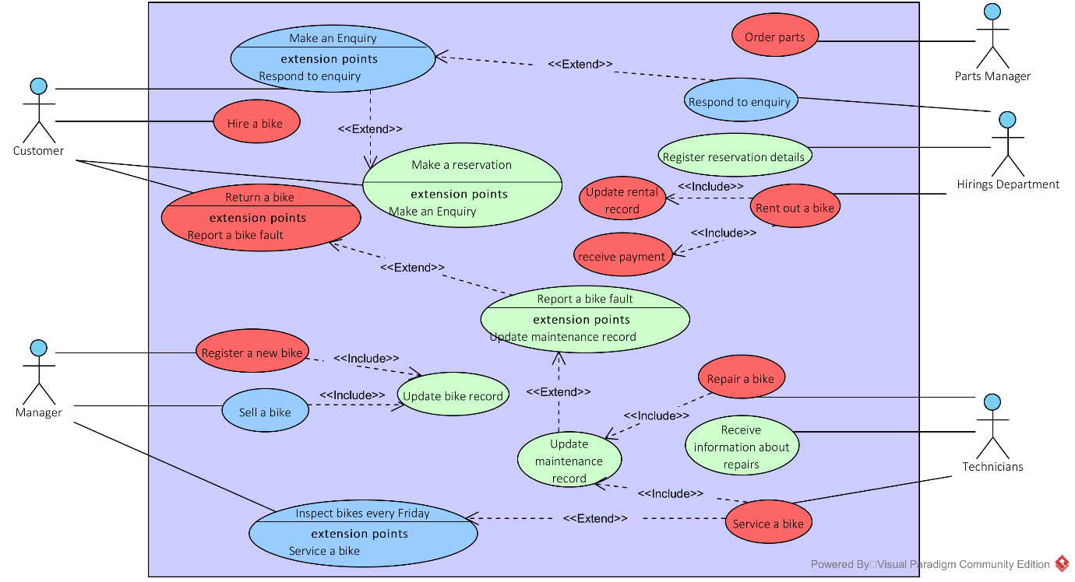

# 3.1 Use Case Specifications

## 3.1.1 Update Customers Record

|  |
| --- |
| **Use Case: Update Customers Record** |
| **Owner**: Manager |
| **Pre-Conditions** |
| 1. No existing Customer Record |
| **Post-Conditions** |
| 1. Customer added to Customer Record |
| **Primary Path** |
| 1. New customer requests an account 2. Customer details acquired 3. Customer details are updated to Customer Record |
| **Alternate Path** |
| 1. Customer details are wrong 2. Customer details are not entered into Customers Record |
| **Notes** |
| Pritam Sangani |

## 3.1.2 Update Maintenance Record

|  |
| --- |
| **Use Case: Update Maintenance Record** |
| Owner: Manager |
| **Pre-Conditions** |
| 1. Customer returns bike reporting a fault. 2. Manager services the bike finding a fault. |
| **Post-Conditions** |
| 1. After the bike fault(s) have been fixed by the technicians, the maintenance record is updated and the bike is ready to be hired out again. |
| **Primary Path** |
| 1. Customer returns bike reporting a fault with the bike. 2. The staff report back the fault to the technicians and make the bike unavailable. 3. The bike is then added to the maintenance record adding the fault with the bike. 4. The maintenance record is updated again once the bike has been fixed. |
| **Alternate Path** |
| 1. No fault is found, by the customer or the manger, with the bike. |
| **Notes** |
| Yusof Bandar |

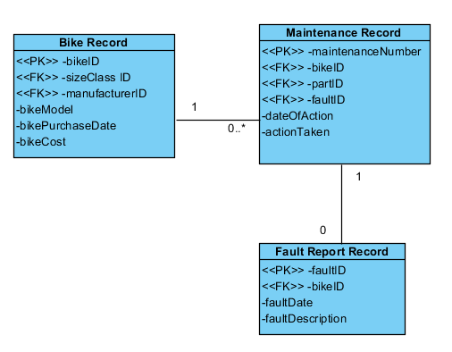

## 3.1.3 Update Bike Record

|  |
| --- |
| **Use Case: Update Bike Record** |
| Owner: Manager |
| **Pre-Conditions** |
| 1. Existing bike record |
| **Post-Conditions** |
| 1. Bike record updated with correct information |
| **Primary Path** |
| 1. New bike(s) is bought by manager from supplier or manufacturer using Manufacturer Record 2. Bike(s) bought is received 3. Bike(s) details are entered into the Bike Record |
| **Alternate Path** |
| 1. Bike bought is never received 2. Cancel order 3. Don’t update Bike Record with new bike details |
| **Notes** |
| Naim Ahmed |

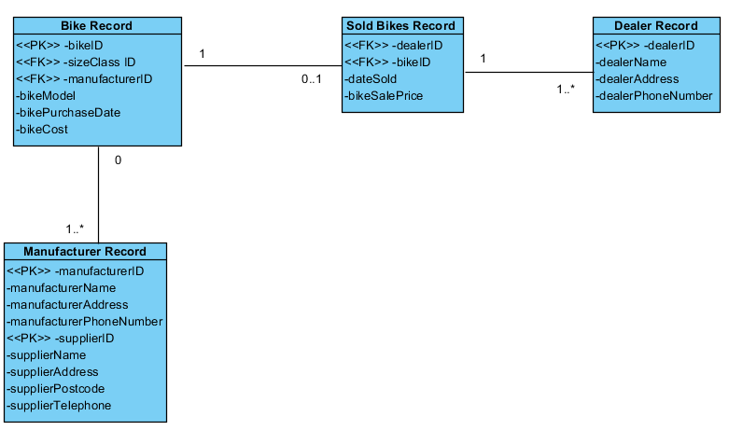

## 3.1.4 Order Parts

|  |
| --- |
| **Use Case: Order Parts** |
| Owner: Parts Manager |
| **Pre-Conditions** |
| 1. Existing Part ID 2. Existing Supplier ID |
| **Post-Conditions** |
| 1. Delivery notice 2. Delivery invoice |
| **Primary Path** |
| 1. Parts Manager does a stock check on what parts are low or out of stock 2. Produce a list of parts which need to be ordered 3. Order parts 4. Update Parts Ordered Record 5. Check all correct parts have arrived using invoice 6. Check for damaged parts 7. Update Supplied Parts Record, with parts arrived and not damaged |
| **Alternate Path** |
| 1. All Parts are in stock |
| **Notes** |
| Aamer Atique |

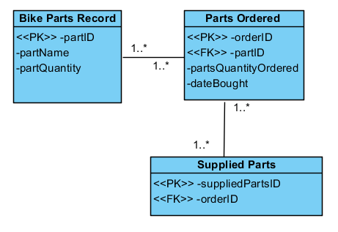

## 3.1.5 Update Rental Record

|  |
| --- |
| **Use Case: Update Rental Record** |
| Owner: Hirings Department |
| **Pre-Conditions** |
| 1. An existing Customer hires an existing bike(s) through the Hirings Department 2. No current reservation on bike(s) 3. Reservation only for primary path |
| **Post-Conditions** |
| 1. Return bike(s) after use |
| **Primary Path** |
| 1. Hirings Department checks Reservation Record 2. Hirings Department finds the bike being hired using bikeID 3. Customer rents out bike 4. Rental Record is updated, time taken out and time due 5. Customer returns bike 6. Rental Record is updated, time due 7. Payment accepted |
| **Alternate Path** |
| 1. Customer asks to rent out a bike in store 2. Hirings Department checks if required bike is available 3. Customer rents out bike 4. Rental Record is updated, time taken out and time due 5. Customer returns bike 6. Rental Record is updated, time due 7. Payment accepted |
|  |
| Faran Azadi |

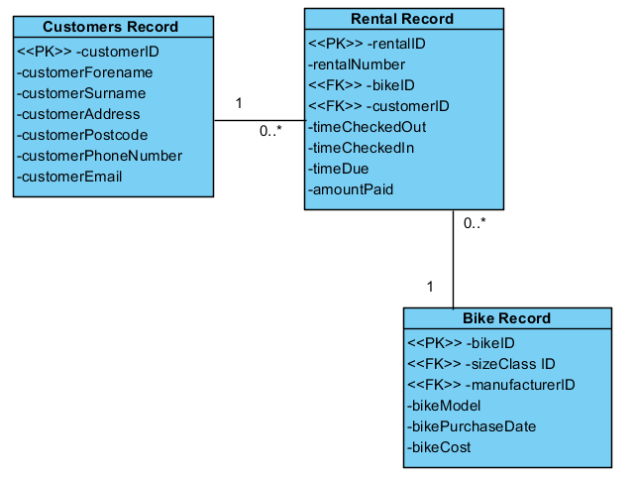

# 4.0 RDAs

## 4.1 Maintenance and Dealer Record RDA

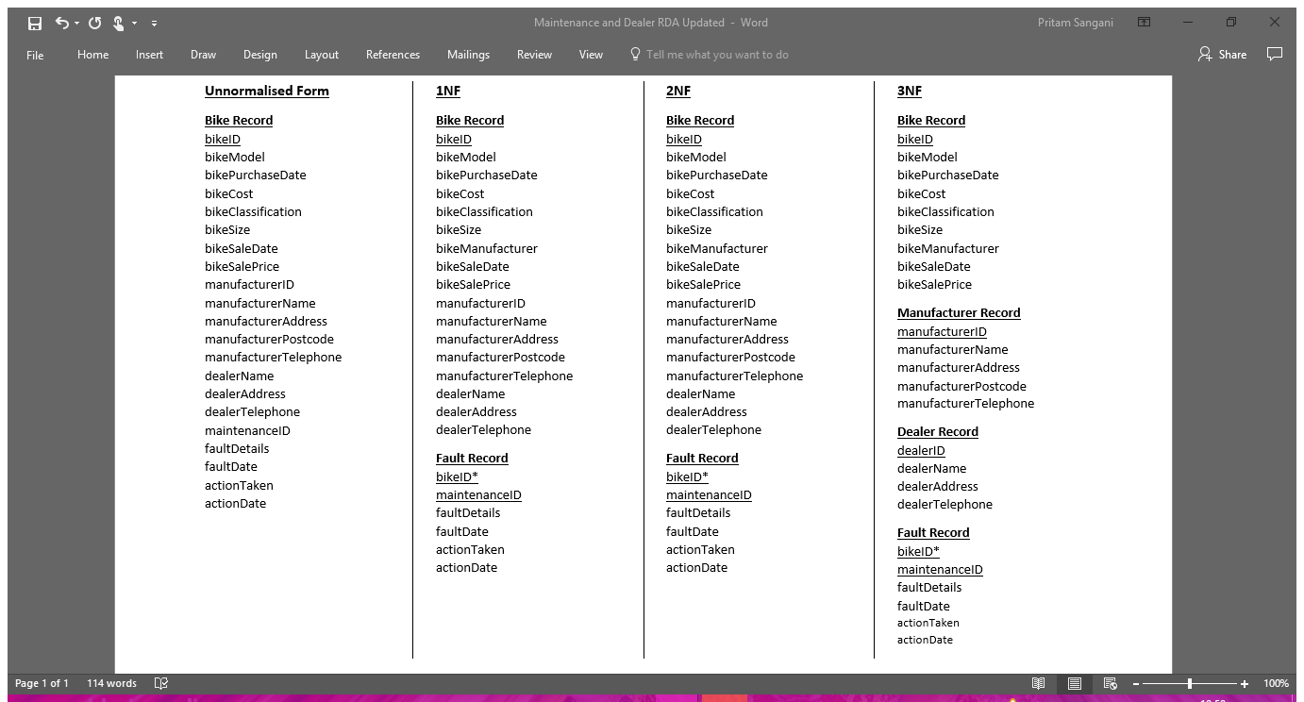

## 4.2 Rental and Bike Record RDA

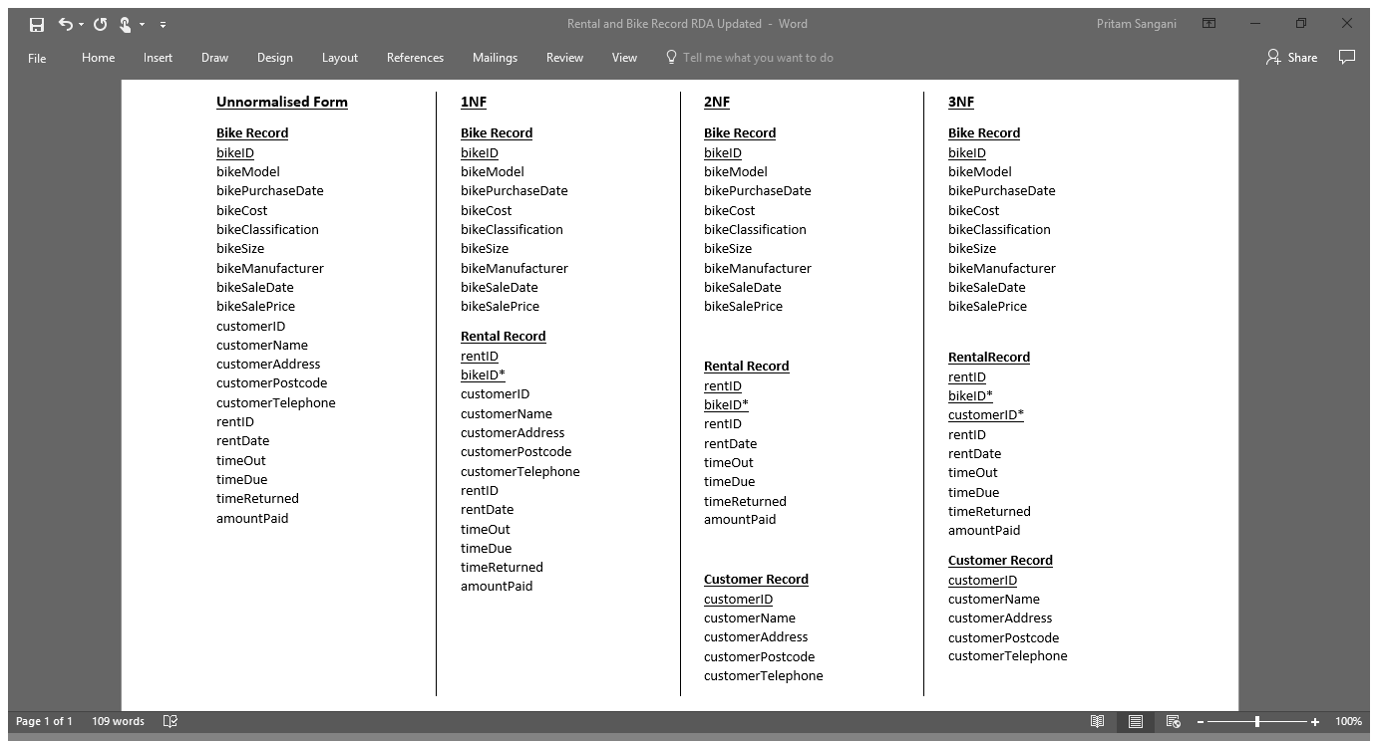

## 4.3 Merged RDA

**Bike Record**  
bikeID  
bikeModel  
bikePurchaseDate  
bikeCost  
bikeClassification  
bikeSize  
bikeSaleDate  
bikeSalePrice  
bikeManufacturer

**Rental Record**  
rentID  
bikeID*  
customerID*  
rentDate  
timeOut  
timeDue  
timeReturned  
amountPaid

**Customer Record**customerID  
customerName  
customerAddress  
customerPostcode  
customerTelephone

**Dealer Record**  
dealerID  
dealerName  
dealerAddress  
dealerTelephone

**Fault Record**  
bikeID*  
maintenanceID*  
faultDetails  
faultDate  
actionTaken  
actionDate

**Manufacturer Record**  
manufacturerID  
manufacturerName  
manufacturerAddress  
manufacturerPostcode  
manufacturerTelephone

# 5.0 ERDs

## 5.1 Top - Down ERD

## 5.2 Bottom – Up ERD of Merged RDA

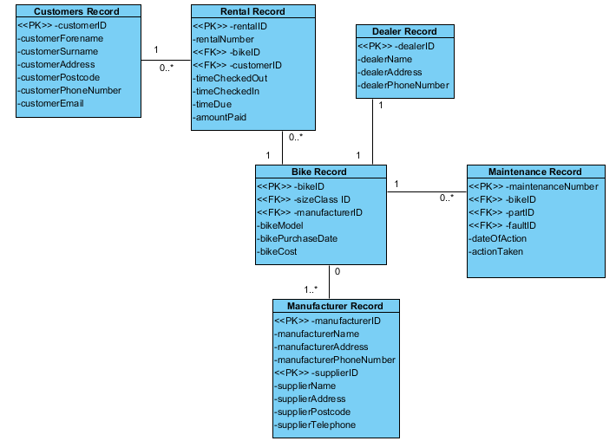

## 5.3 Finalised Group ERD

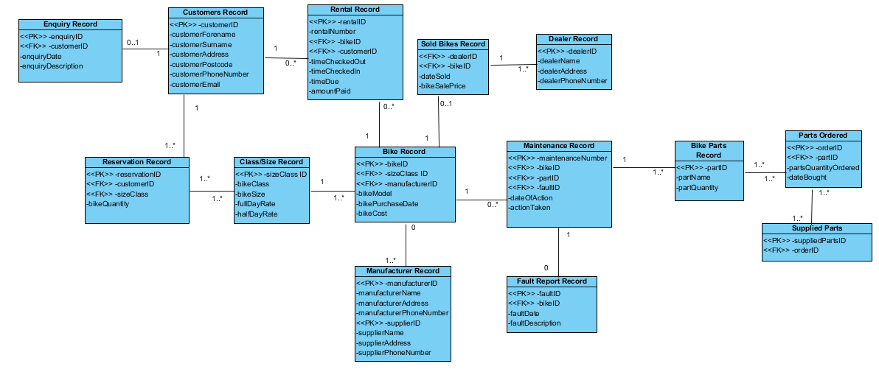

## 5.4 Commentary of ERD Creation

There were many decisions which were made to create our final ERD. For example, for the enquiries record, we assumed that some customers may not enquire about bikes and may just come in and rent the bikes straight from the shop or may just make a reservation without enquiring. For the relationships between the entities, we went through different scenarios which could happen and decided which relationship would make sense. Going through many examples of different ERDs allowed us to get a better understanding of how they work and the relationships between the entities. For many to many relationships, we had to create new weak entities to split the relationships.

# 6.0 Amended Group ERD

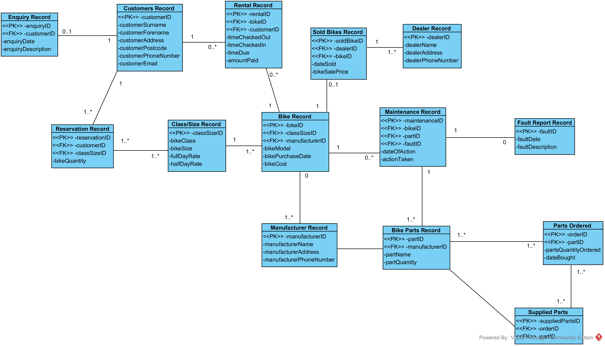

# 7.0 Data Dictionaries

## 7.1 Rental Record

|  |  |  |  |  |  |  |
| --- | --- | --- | --- | --- | --- | --- |
| **Attribute Name** | **Key Type** | **FK Table** | **FK Column** | **Data Type** | **Length** | **Constraint** |
| rentalID | PK |  |  | NUMBER | 9 |  |
| bikeID | FK | bikeRecord | bikeID | NUMBER | 9 |  |
| customerID | FK | customersRecord | customerID | NUMBER | 9 |  |
| timeCheckedOut |  |  |  | DATE |  | NOT NULL |
| timeCheckedIn |  |  |  | DATE |  | NOT NULL |
| timeDue |  |  |  | DATE |  | NOT NULL |
| amountPaid |  |  |  | NUMBER | (5,2) |  |

## 7.2 Reservation Record

|  |  |  |  |  |  |  |
| --- | --- | --- | --- | --- | --- | --- |
| **Attribute Name** | **Key Type** | **FK Table** | **FK Column** | **Data Type** | **Length** | **Constraint** |
| reservationID | PK |  |  | NUMBER | 9 |  |
| customerID | FK | customersRecord | customerID | NUMBER | 9 |  |
| classSizeID | FK | classSizeRecord | sizeClassID | NUMBER | 9 |  |
| bikeQuantity |  |  |  | NUMBER | 3 |  |

## 7.3 Dealer Record

|  |  |  |  |  |  |  |
| --- | --- | --- | --- | --- | --- | --- |
| **Attribute Name** | **Key Type** | **FK Table** | **FK Column** | **Data Type** | **Length** | **Constraint** |
| dealerID | PK |  |  | NUMBER | 9 |  |
| dealerName |  |  |  | VARCHAR2 | 30 | NOT NULL |
| dealerAddress |  |  |  | VARCHAR2 | 45 |  |
| dealerPhoneNumber |  |  |  | NUMBER | 13 | NOT NULL, UNIQUE |

## 7.4 Fault Report Record

|  |  |  |  |  |  |  |
| --- | --- | --- | --- | --- | --- | --- |
| **Attribute Name** | **Key Type** | **FK Table** | **FK Column** | **Data Type** | **Length** | **Constraint** |
| faultID | PK |  |  | NUMBER | 9 |  |
| bikeID | FK | bikeRecord | bikeID | NUMBER | 9 |  |
| faultDate |  |  |  | DATE |  |  |
| faultDesc |  |  |  | VARCHAR2 | 140 |  |

## 7.5 Customers Record

|  |  |  |  |  |  |  |
| --- | --- | --- | --- | --- | --- | --- |
| **Attribute Name** | **Key Type** | **FK Table** | **FK Column** | **Data Type** | **Length** | **Constraint** |
| customerID | PK |  |  | NUMBER | 9 |  |
| customerSurname |  |  |  | VARCHAR2 | 30 | NOT NULL |
| customerForename |  |  |  | VARCHAR2 | 30 |  |
| customerAddress |  |  |  | VARCHAR2 | 45 |  |
| customerPostcode |  |  |  | VARCHAR2 | 8 | NOT NULL |
| customerPhoneNumber |  |  |  | NUMBER | 13 | NOT NULL, UNIQUE |
| customerEmail |  |  |  | VARCHAR2 | 45 | UNIQUE |

## 7.6 Enquiry Record

|  |  |  |  |  |  |  |
| --- | --- | --- | --- | --- | --- | --- |
| **Attribute Name** | **Key Type** | **FK Table** | **FK Column** | **Data Type** | **Length** | **Constraint** |
| enquiryID | PK |  |  | NUMBER | 9 |  |
| customerID | FK | customersRecord | customerID | NUMBER | 9 |  |
| enquiryDate |  |  |  | DATE |  |  |
| enquiryDesc |  |  |  | VARCHAR2 | 140 |  |

## 7.7 Sold Bikes Record

|  |  |  |  |  |  |  |
| --- | --- | --- | --- | --- | --- | --- |
| **Attribute Name** | **Key Type** | **FK Table** | **FK Column** | **Data Type** | **Length** | **Constraint** |
| soldBikeID | PK |  |  | NUMBER | 9 |  |
| dealerID | FK | dealerRecord | dealerID | NUMBER | 9 |  |
| bikeID | FK | bikeRecord | bikeID | NUMBER | 9 |  |
| dateSold |  |  |  | DATE |  | NOT NULL |
| bikeSalePrice |  |  |  | NUMBER | (7, 2) |  |

## 7.8 Bike Record

|  |  |  |  |  |  |  |
| --- | --- | --- | --- | --- | --- | --- |
| **Attribute Name** | **Key Type** | **FK Table** | **FK Column** | **Data Type** | **Length** | **Constraint** |
| bikeID | PK |  |  | NUMBER | 9 |  |
| classSizeID | FK | classSizeRecord | classSizeID | NUMBER | 9 |  |
| manufacturerID | FK | manufacturerRecord | manufacturerID | NUMBER | 9 |  |
| bikeModel |  |  |  | VARCHAR2 | 20 |  |
| bikePurchaseDate |  |  |  | DATE |  |  |
| bikeCost |  |  |  | NUMBER | (7,2) |  |

## 7.9 Class / Size Record

|  |  |  |  |  |  |  |
| --- | --- | --- | --- | --- | --- | --- |
| **Attribute Name** | **Key Type** | **FK Table** | **FK Column** | **Data Type** | **Length** | **Constraint** |
| classSizeID | PK |  |  | NUMBER | 9 |  |
| bikeClass |  |  |  | VARCHAR2 | 15 |  |
| bikeSize |  |  |  | VARCHAR2 | 20 |  |
| fullDayRate |  |  |  | NUMBER | (5,2) |  |
| halfDayRate |  |  |  | NUMBER | (5,2) |  |

## 7.10 Maintenance Record

|  |  |  |  |  |  |  |
| --- | --- | --- | --- | --- | --- | --- |
| **Attribute Name** | **Key Type** | **FK Table** | **FK Column** | **Data Type** | **Length** | **Constraint** |
| maintenanceID | PK |  |  | NUMBER | 9 |  |
| bikeID | FK | bikeRecord | bikeID | NUMBER | 9 |  |
| partID | FK | bikePartsRecord | partID | NUMBER | 9 |  |
| faultID | FK | faultReportRecord | faultID | NUMBER | 9 |  |
| dateOfAction |  |  |  | DATE |  |  |
| actionTaken |  |  |  | VARCHAR2 | 140 |  |

## 7.11 Bike Parts Record

|  |  |  |  |  |  |  |
| --- | --- | --- | --- | --- | --- | --- |
| **Attribute Name** | **Key Type** | **FK Table** | **FK Column** | **Data Type** | **Length** | **Constraint** |
| partID | PK |  |  | NUMBER | 9 |  |
| manufacturerID | FK | manufacturerRecord | manufacturerID | NUMBER | 9 |  |
| partName |  |  |  | VARCHAR2 | 30 | NOT NULL |
| partQuantity |  |  |  | NUMBER | 5 | NOT NULL |

## 7.12 Supplied Parts Record

|  |  |  |  |  |  |  |
| --- | --- | --- | --- | --- | --- | --- |
| **Attribute Name** | **Key Type** | **FK Table** | **FK Column** | **Data Type** | **Length** | **Constraint** |
| suppliedPartsID | PK |  |  | NUMBER | 9 |  |
| orderID | FK | orderedPartsRecord | orderID | NUMBER | 9 |  |
| partID | FK | bikePartsRecord | partID | NUMBER | 9 |  |

## 7.13 Ordered Parts Record

|  |  |  |  |  |  |  |
| --- | --- | --- | --- | --- | --- | --- |
| **Attribute Name** | **Key Type** | **FK Table** | **FK Column** | **Data Type** | **Length** | **Constraint** |
| orderID | PK |  |  | NUMBER | 9 |  |
| partID | FK | bikePartsRecord | partID | NUMBER | 9 |  |
| partsQtyOrdered |  |  |  | NUMBER | 30 | NOT NULL |
| dateBought |  |  |  | DATE |  |  |

## 7.14 Manufacturer Record

|  |  |  |  |  |  |  |
| --- | --- | --- | --- | --- | --- | --- |
| **Attribute Name** | **Key Type** | **FK Table** | **FK Column** | **Data Type** | **Length** | **Constraint** |
| manufacturerID | PK |  |  | NUMBER | 9 |  |
| manufacturerName |  |  |  | VARCHAR2 | 45 | NOT NULL |
| manufacturerAddress |  |  |  | VARCHAR2 | 60 | NOT NULL |
| manufacturerPhoneNumber |  |  |  | NUMBER | 13 | NOT NULL |

# 8.0 Reflection on what has been learnt doing SQL

## 8.1 Aamer Atique

This assignment has helped me in learning some very useful skills and since it was a much more of a practical assignment where we had to create a database, my understanding of it has improved immensely. It has proved very useful knowing and understanding what an ERD is to understand the links between each table and how the database will work and communicate with all of its various parts. Creating data dictionaries has also done this as it has helped me understand what the appropriate data type for each attribute should be - I researched the different data types in SQL to help me with this.

Using SQL has helped me learn how, why and where it is used. We used SQL to create queries which were a part of our assignment. Overcoming errors with SQL was challenging, however, was easy to overcome with the help of others. Creating a database in ORACLE was the main part of this assignment and it was interesting how we went from turning our ERD into an actual database which we learnt well through doing it. Overall, I feel I have benefitted from this part of the assignment.

## 8.2 Faran Azadi

In part 3 of this assignment, I encountered some new concepts and also put some things I had learnt from lectures/labs into practice. I found that implementing them into an actual solution benefited me tremendously as I think it is one thing to listen to a teacher talk about something, but to actually do it yourself can only improve your knowledge. As they say, practice makes perfect.

Amending our ERD highlighted the importance of the relationships between the entities in the database to me – one bad relationship can affect everything. Creating the data dictionaries for each table made me realise how simple it is to create the tables once all the thought has already been put into them in regards to the appropriate data types, field lengths, attribute names and field constraints. Another major thing for me in this assignment was gaining experience writing queries. Not only did I practice using functions/operators and make use of an inner join, but I had a lot more time to get used to SQL Developer and APEX.

## 8.3 Naim Ahmed

During this part of the assignment, there are many skills which I have managed to obtain in this short span of time. I’ve learnt how to create data dictionaries for each of the tables that will be created for the database and seen how useful they are when it comes to creating the database. I’ve expanded my knowledge of the different data types which are available to be used in databases and why different data types are used for different values such as dates and strings.

I’ve also learned how to use data manipulating software that is used in the information technology industry which businesses use, such as, Oracle SQL Developer and APEX, an online application which can be used to make databases. Learning the process of how to create queries to gather the data which you need has allowed me to understand why these programs, such as, SQL Developer are so important to businesses who have large amounts of data, as using queries allows you to obtain the data you need to make business decisions.

## 8.4 Yusof Bandar

Finishing and amending our final ERD solidified my understanding of ERDs, fully understanding the way the relationships and weak entities work. Furthermore, using the data dictionary gave me a firm understanding of different data types, such as, VARCHAR2 and NUMBER() to format the data, also learning what types of constraints there are and how they operate.

Creating tables, inserting and selecting data using SQL Developer and APEX gave me understanding on how SQL works. Firstly, simply learning the syntax for SQL and avoiding common errors furthered my understanding. Additionally, using complex data types such as DATE and TIMESTAMP helped me to recognise how SQL stores data and how to avoid string errors. Overall, I learnt how SQL scripts and queries work, also learning how to write data dictionaries.

## 8.5 Pritam Sangani

Creating data dictionaries has helped me learn about the different data types in SQL, such as, NUMBER, DATE and VARCHAR2. I was also able to determine which data type was best to use for each attribute. I was able to understand the importance of creating data dictionaries before implementing the database in ORACLE as it helped to think about what constraints and relationships there were between entities before creating the tables.

While implementing the database in ORACLE SQL Developer and APEX, I learnt about the syntax in SQL, such as, CREATE, DROP, INSERT INTO and SELECT. I learnt how to create tables, insert data in the tables and how to run queries using the syntax that I had learnt.

# 9.0 Conclusion

## 9.1 Aamer Atique

During this assignment, I have learned and improved many useful skills which I will use for the duration of my career. Probably the most important skill is the ability to form and communicate a productive team. This was crucial as a group that doesn’t work together would be useless as it defeats the purpose. I was fortunate enough to have a team which understood the value of hard work and dedication. I also learned how a company would deal with being tasked with creating a database for a business like Ray’s Rentals. Building the database was another important skill to learn as it required a lot of thinking and checking to make sure we met the criteria. I’ve also learned the importance of ERDs. Without ERDs the construction of the database would have been far more difficult. I found that the ERDs proved to be very useful. Overall, I would say I have benefitted greatly in this subject area as it has given my confidence for working in this field in the future.

## 9.2 Faran Azadi

## 9.3 Naim Ahmed

Throughout this assignment I have learnt many different skills associated with systems development. Many of which may come in use to me in the future in my future career.

In part one I got to learn about current systems that are usually used for many businesses that operate around the world and the problems associated with these system (mainly paper based systems). Also, learning the different types of reports that a business produces such as management reports and what they mean for the business. I have improved on my group skills by working in a team and communicating with the people in my group.

The second part of the assignment was heavily focused on Use Case Diagrams (UCD) and Entity Relationship Diagram (ERD). This allowed me to develop my skill of working together within a group and building my communication skills as it was a big task creating a ERD. I had to learn about what ERDs include and looking at example ERDs and finding out about different types of relationships such as one-to-one, one-to-many and many-to-many.

In part three I learnt about data dictionaries by creating some for the Lee’s Bike Shop. This allowed me to learn about different types of keys such as primary and foreign keys and what each are used for and different types of attributes such as ‘NOT NULL’ as well as different types of variables like varchar, time and date. This fit in nicely by learning how to use ORACLE software in implementing the database table designs. Also, I developed my understanding of SQL and how useful they can be to businesses in being able to obtain the data you need for a specific case. I was then able to create my own SQL queries for different scenarios for the businesses which may occur such as finding out the quantity for a certain part of a bike.

## 9.4 Yusof Bandar

Information Systems is the process of information by humans and computers, completing this report I have learnt a great deal about how to implement an information system into a small company, also learning the processes behind the implementation and the importance of each process.

Furthermore, I have gained experience on how to write correct Use Cases and ERD’s, how use cases are needed to visualise the systems and demonstrate how it works to the customer and how use case specifications are used to show how each use case will function but also demonstrate how the front end might function.

I also learned the difference between Top-Down ERDs and Bottom-Up ERDs and how each one functions collating together to form a final ERD. To obtain a final Bottom-Up ERD we had to normalise to 3rd Normal form; I learnt how each normal form functions and the purpose for each one. Practising normalisation and Top-Down design solidified my understanding on how to write a final ERD for the future.

The final part of the report was using Oracle and SQL. In this part of the report this is where I learnt how to create the final database using the final ERD we had created previously. We had to learn and use two programs, Oracle SQL Developer and APEX which showed me the advantages and disadvantages of both programs. I also had to learn the syntax of SQL and how it functions to provide us with relevant queries, and how to create and insert the data into our database.

## 9.5 Pritam Sangani

Throughout completing this project, I have picked up a lot of skills required to plan and produce an information system. I have learnt the importance of each stage of the Waterfall Model and how each helps in planning and creating the system.

For the first stage of the Waterfall Model – Requirements Analysis, I learnt the theory of management reports and developed my analysis skills to analyse a specification to draw up a list of problems and system requirements.

I found the second stage – System Design – the trickiest as it required a lot of thinking and discussion with my team. However, I picked up a lot of knowledge in how to create a Use Case Diagram (UCD) and implement that to produce an Entity Relationship Diagram (ERD). I learnt about the difference between a top-down ERD and a bottom-up ERD and why we create both and then merge. Whilst doing this, I learnt how to use Visual Paradigm, the software I used to draw the ERD and UCD.

My favourite stage to complete was the third stage, the Implementation stage. I enjoyed this as I found SQL, the language used to code the database in, quite intuitive and found that you can manipulate the data within the database quite easily using queries in SQL. I quickly picked up the syntax in SQL as it reads quite similarly to common English. For this stage, I learnt how to use two pieces of software – SQL Developer and ORACLE APEX.

Overall, I have developed existing skills, such as teamwork, communication and writing reports, as well as picking up new skills, such as creating ERDs and UCDs. I have enjoyed this project as I have seen first-hand how to plan and implement an information system.

# 10.0 Appendices

## 10.1 References

Chewning, C. (2013, July 21). *Exception Reporting- Improving Key Business Drivers*. Retrieved from Accounting Library: www.accountinglibrary.com/blog/exception-reporting-2/

Whiteley, D. (2013). *An Introduction to Information Systems.* Palgrave Macmillan.

## 10.2 Appendix A: Log Book

### 10.2.1 Part 1

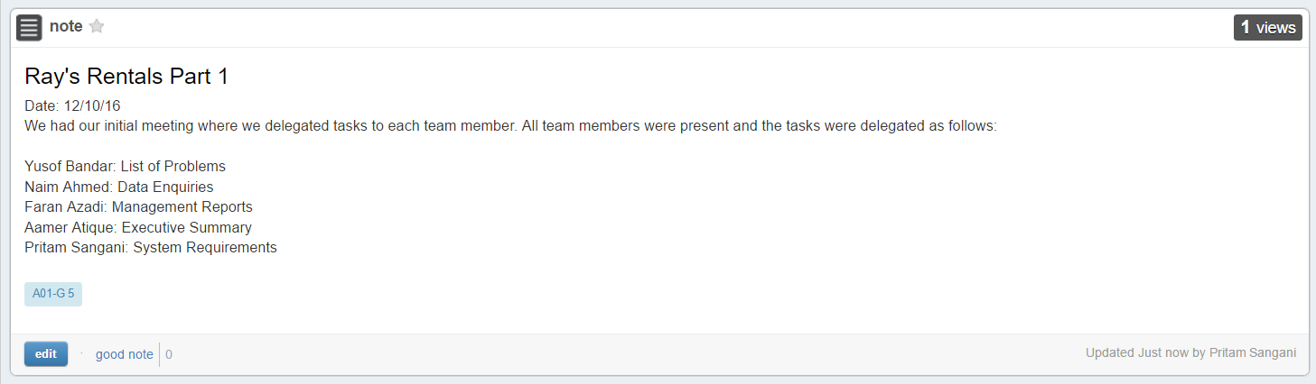

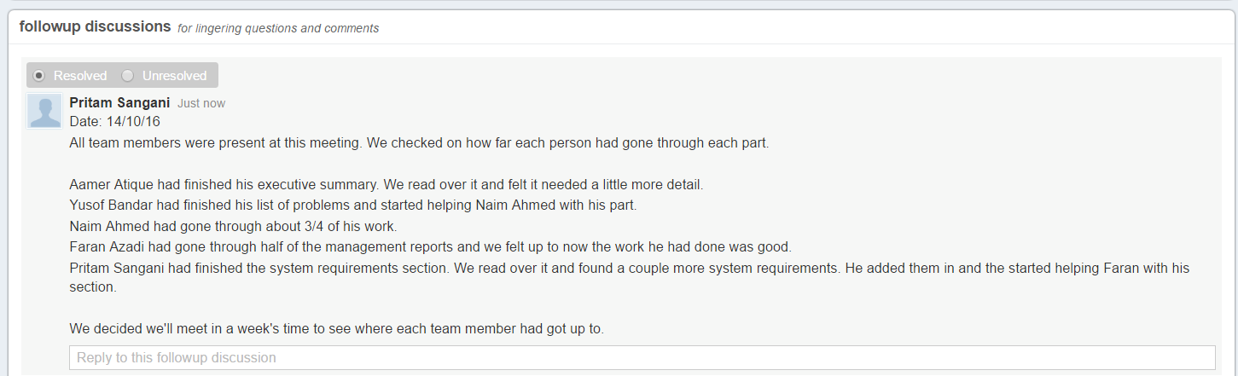

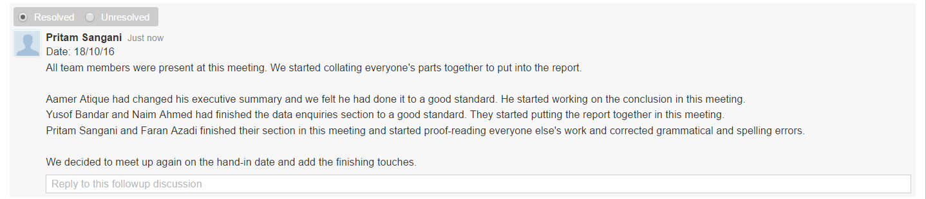

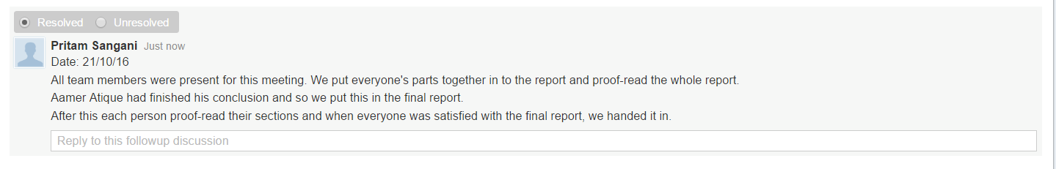

### 10.2.2 Part 2

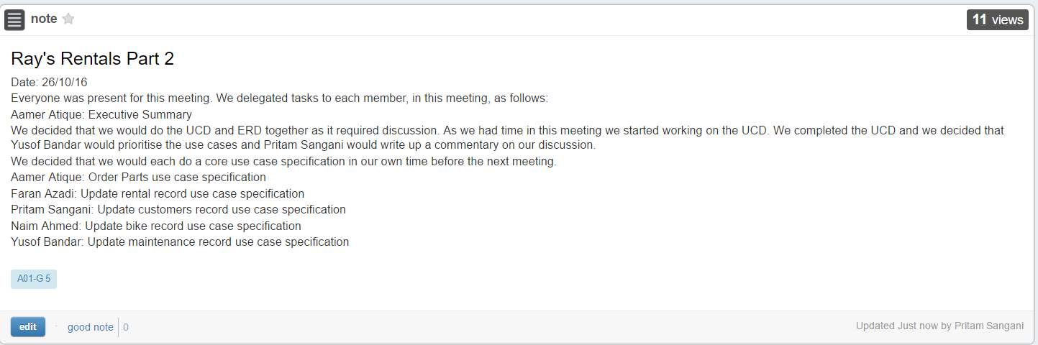

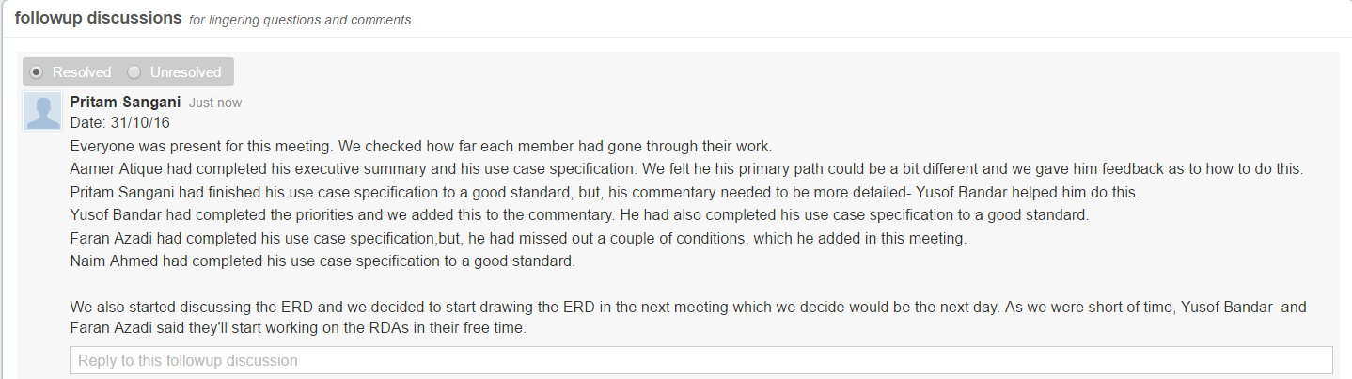

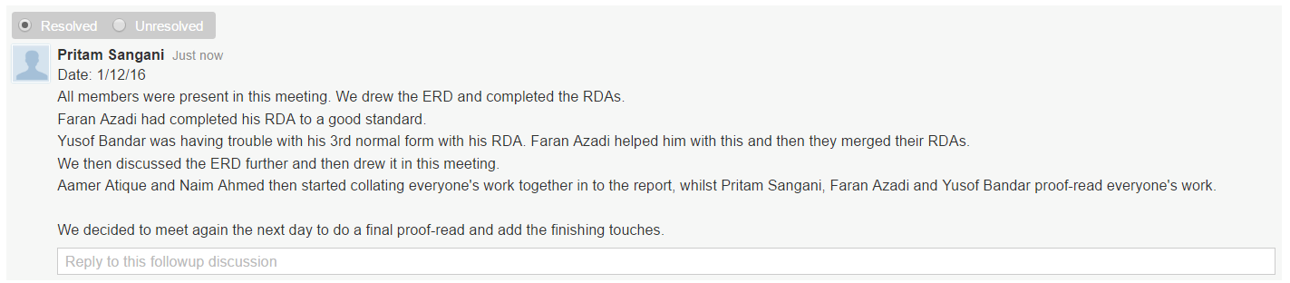

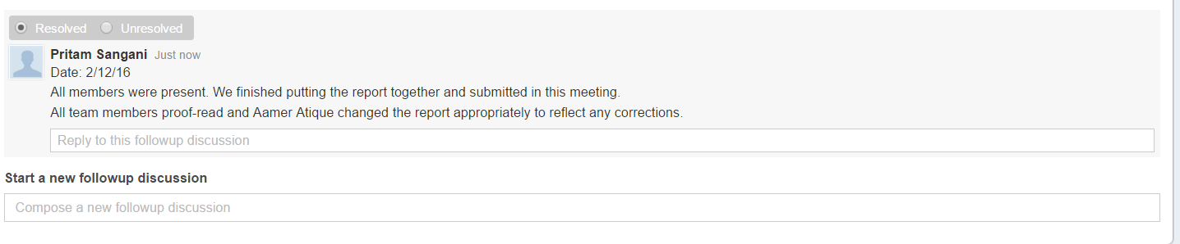

### 

### 10.2.3 Part 3

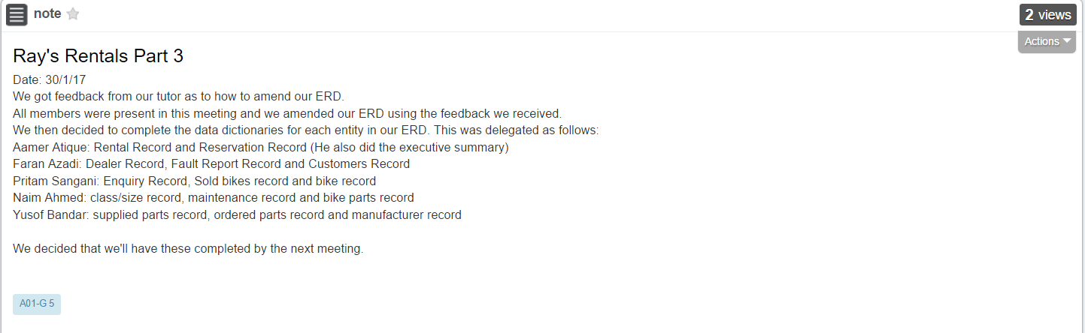

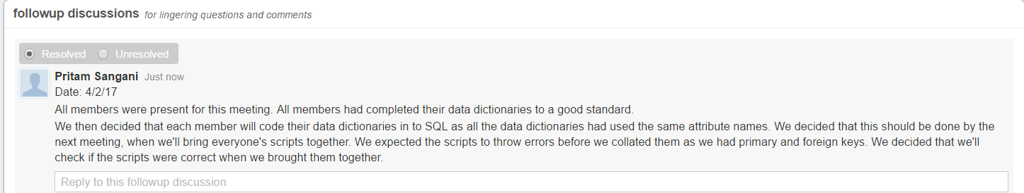

### 

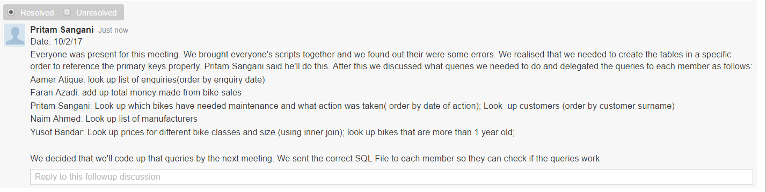

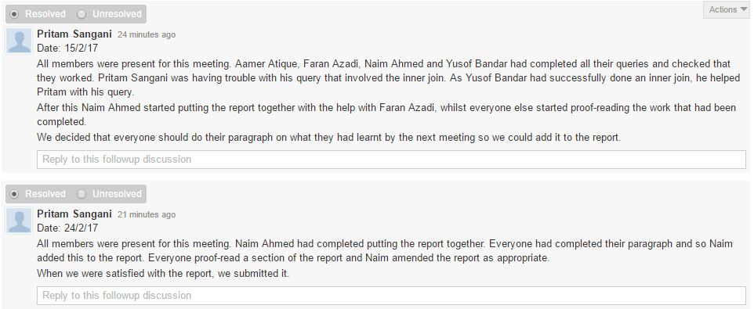

### 10.2.4 Part 4

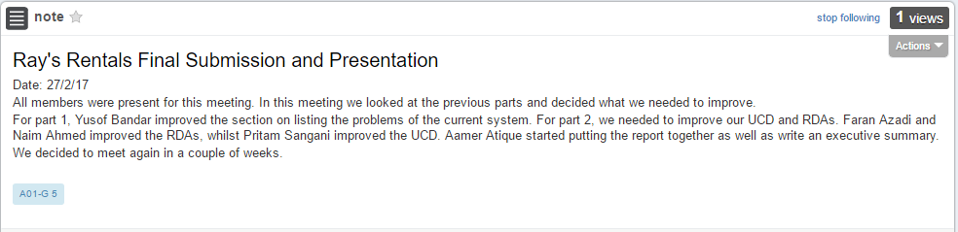

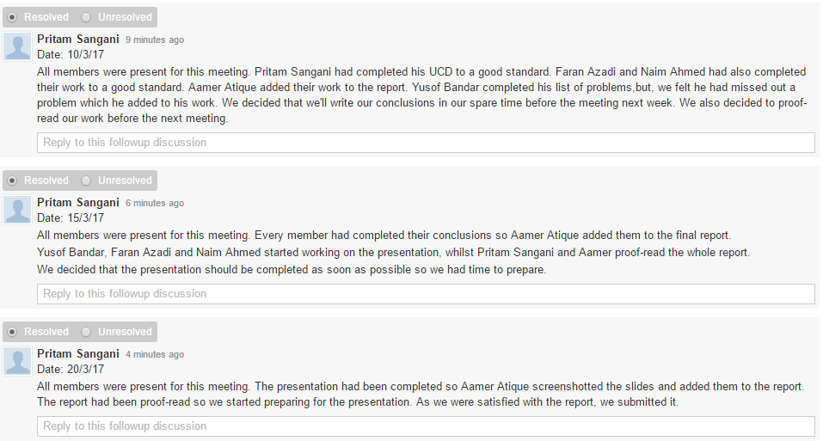

## 10.3 Appendix B: Presentation Slides

